Introduction to Natural Language Processing (NLP)
Natural Language Processing (NLP) helps computers understand, interpret and produce human language. It studies language as data and develops a model that can analyse linguistic structure, meaning and context in both written and spoken communication.
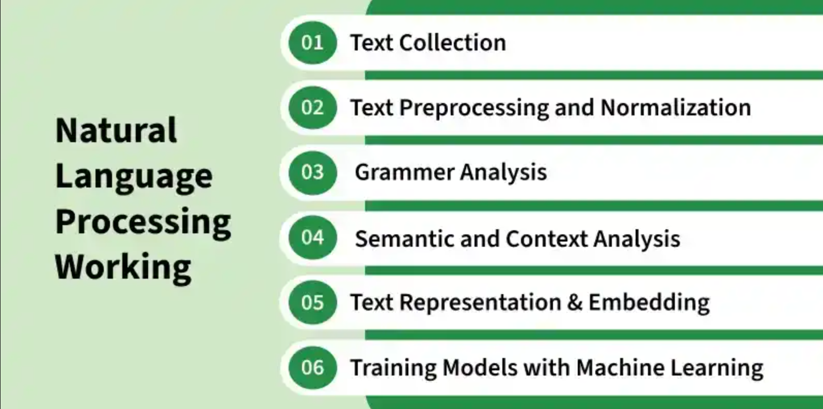
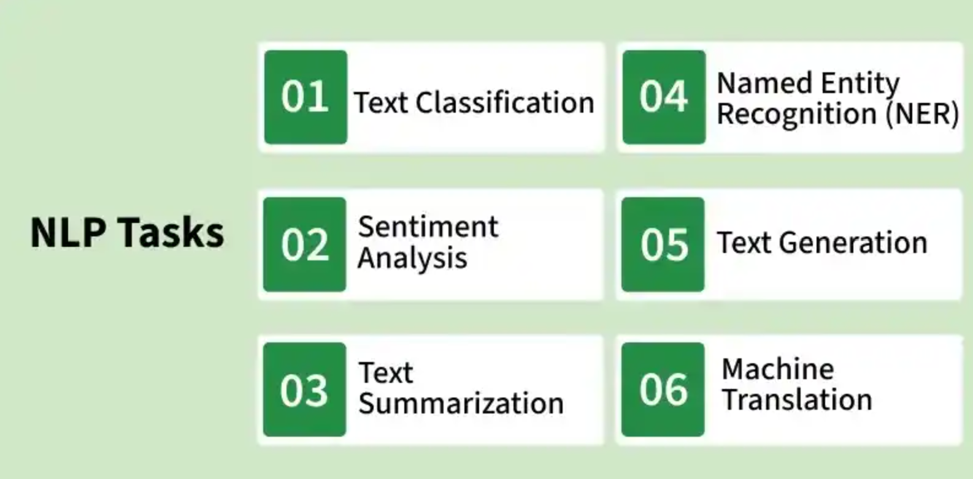
Simple Example of NLP: “Ravi is happy with the new phone.”
An NLP system can:
- Detect Ravi as a person
- Identify phone as an object
- Recognize sentiment as positive
- Understand topic as product review

Libraries
Some of natural language processing libraries include:
- NLTK (Natural Language Toolkit)
- spaCy
- TextBlob
- Transformers (by Hugging Face)
- Gensim
- NLP Libraries

Text Preprocessing Techniques
Preprocessing is an important to clean and prepare the raw text data for analysis. Common preprocessing steps include:
- Tokenization
- Stopword Removal
- Punctuation Removal
- Stemming
- Lemmatization
- Text Normalization
- Parts of Speech (POS) Tagging
- Parsing

Text Representation and Embedding Techniques
- One-Hot Encoding
- Bag of Words (BOW)
- Term Frequency-Inverse Document Frequency (TF-IDF)
- N-Gram Language Modeling
- Latent Semantic Analysis (LSA)
- Latent Dirichlet Allocation (LDA)

Text Embedding Techniques
- Word Embedding: Word2Vec, GloVe, fastText
- Pre-Trained Embedding: ELMo, BERT
- Document Embedding: Doc2Vec
- Advanced Embeddings: RoBERTa, DistilBERT

Traditional Machine Learning
- Naive Bayes
- Logistic Regression
- SVM
- Random Forest

Deep Learning Techniques
- Artificial Neural Networks (ANNs)
- Recurrent Neural Networks (RNNs)
- Long Short-Term Memory (LSTM)
- Gated Recurrent Unit (GRU)
- Seq2Seq Models
- Transformer Models

NLP Tasks
Core NLP tasks that help machines understand, interpret and generate human language.
- Text Classification: Dataset for Text Classification, Naive Bayes, Logistic Regression, RNNs, CNNs
- Information Extraction Named Entity Recognition (NER), NLTK, Relationship Extraction, Word Sense Disambiguation (WSD)
- Sentiment Analysis: VADER, RNN, Opinion Mining
- Machine Translation: Statistical Machine Translation of Language, Machine Translation with Transformer
- Text Summarization: Hugging Face Model, Sumy
- Text Generation: Fnet, LSTM, HuggingFace Model
- Question Answering: Retrieval-Based QA, Generative QA

NLTK - NLP
Natural Language Processing (NLP) plays an important role in enabling machines to understand and generate human language. Natural Language Toolkit (NLTK) stands out as one of the most widely used libraries. It provides a combination linguistic resources, including text processing libraries and pre-trained models, which makes it ideal for both academic research and practical applications.
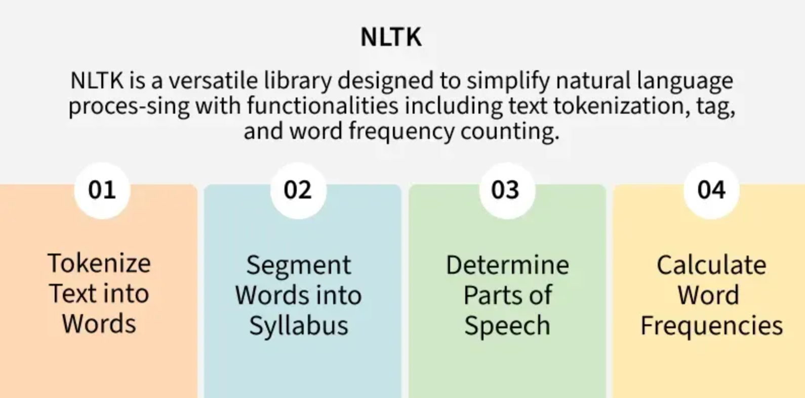

1. Tokenization
2. Stemming and Lemmatization
3. Part of Speech Tagging
4. Named Entity Recognition (NER)

Introduction to Stemming
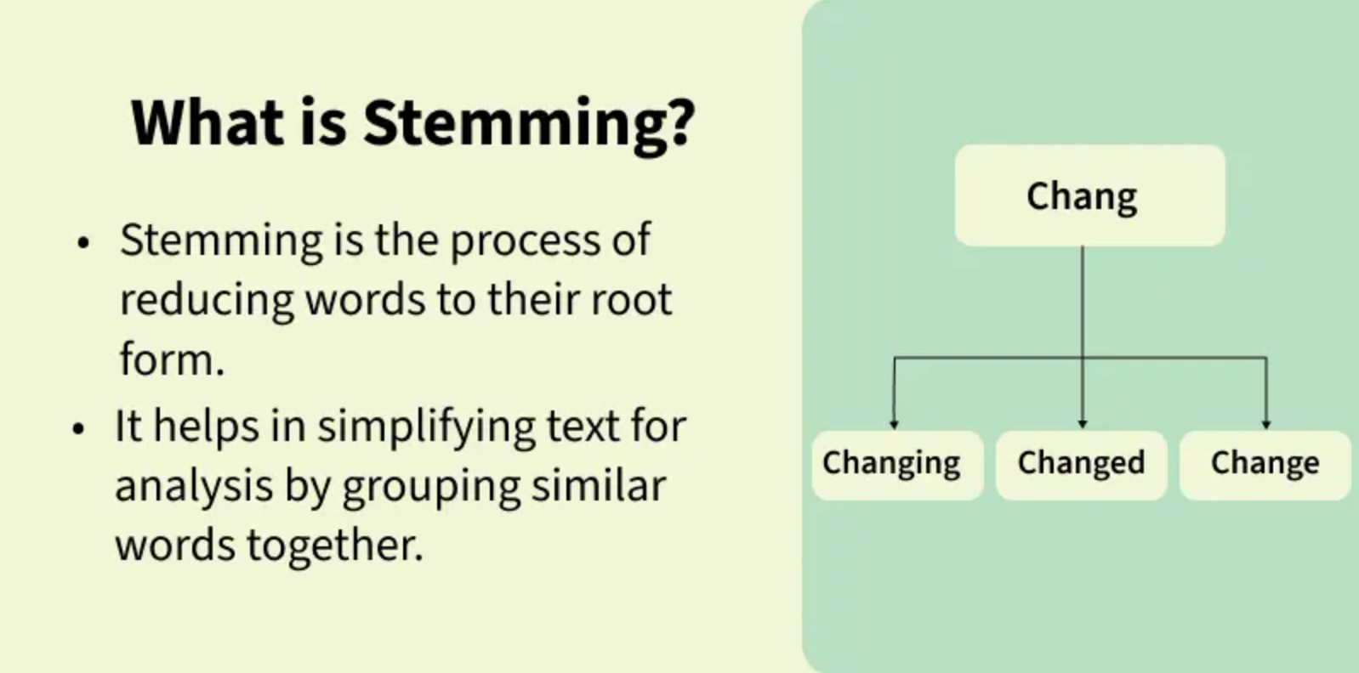
'running' → 'run', 'quickly' → 'quick', ‘happily’ ‘happy’
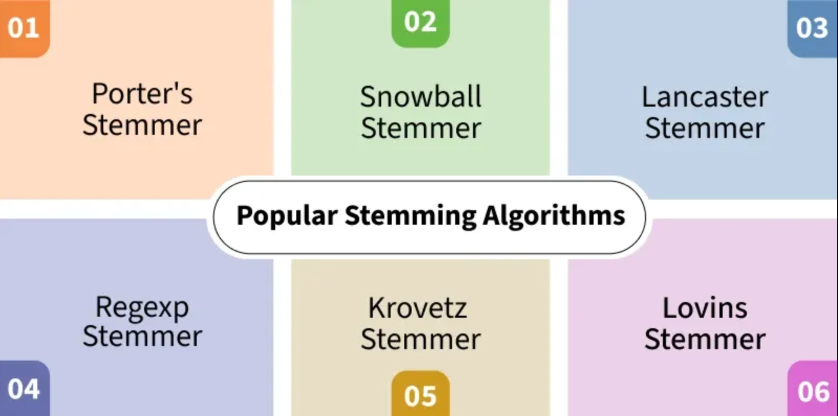
Stemming vs. Lemmatization
Stemming | Lemmatization
Reduces words to their root form often resulting in non-valid words. | Reduces words to their base form (lemma) ensuring a valid word.
Based on simple rules or algorithms. | Considers the word's meaning and context to return the base form.
May not always produce a valid word. | Always produces a valid word.
Example: "Better" → "bet" | Example: "Better" → "good"
No context is considered. | Considers the context and part of speech

Lemmatization with NLTK
Lemmatization is an important text pre-processing technique in Natural Language Processing (NLP) that reduces words to their base form known as a "lemma." For example, the lemma of "running" is "run" and "better" becomes "good."
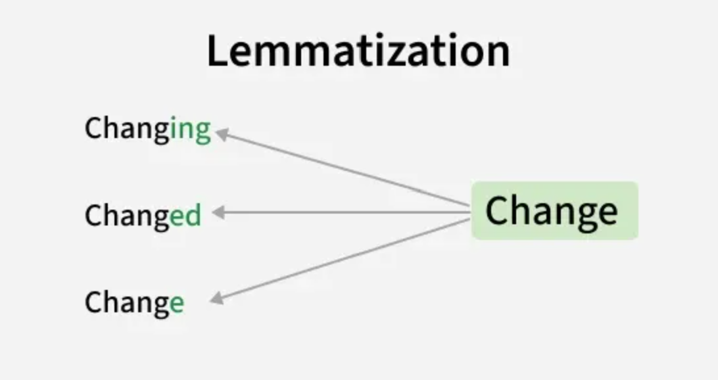

POS(Parts-Of-Speech) Tagging in NLP
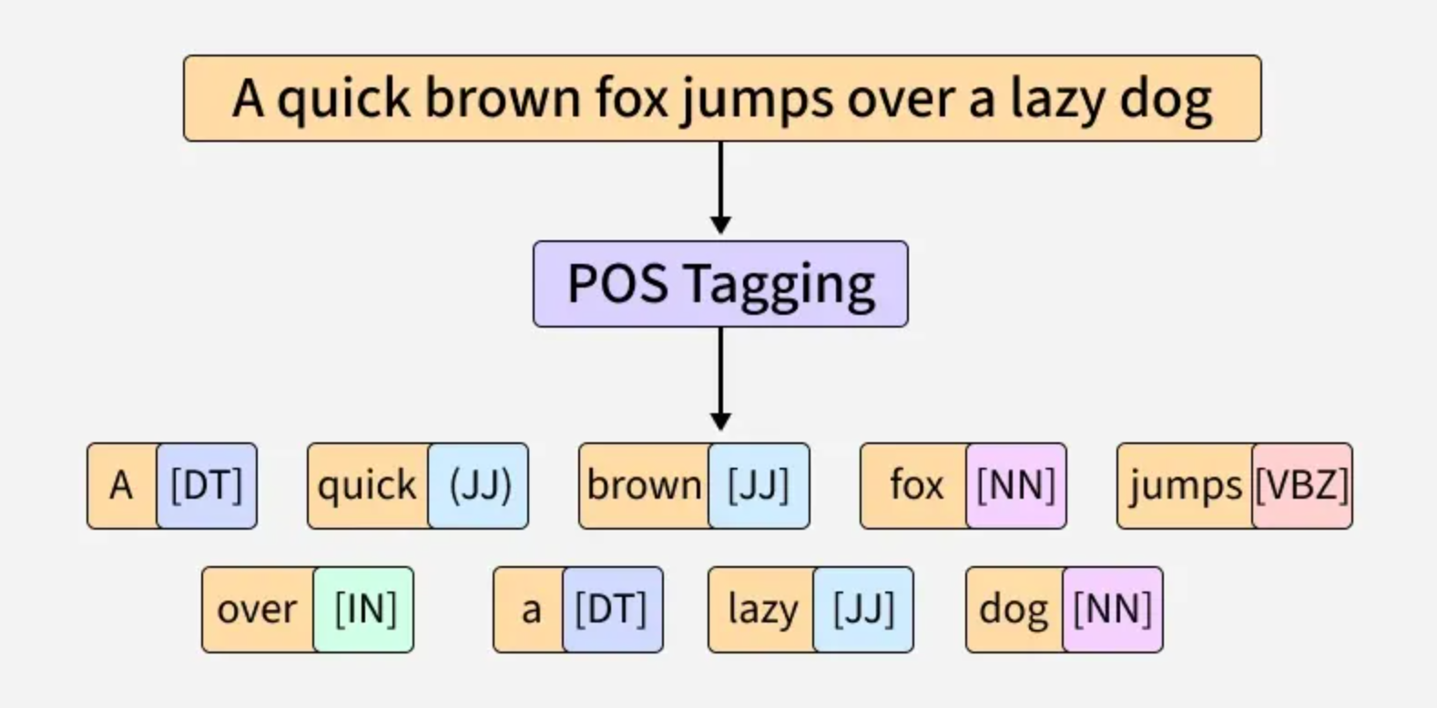
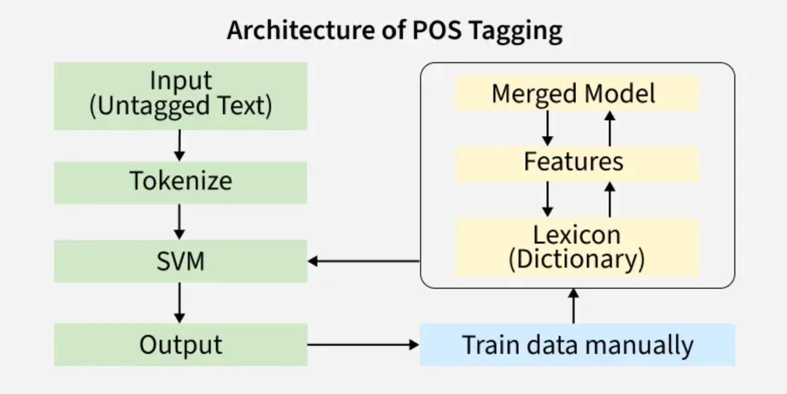
Key Concepts in POS Tagging
- Parts of Speech: These are categories like nouns, verbs, adjectives, adverbs, etc that define the role of a word in a sentence.
- Tagging: The process of assigning a specific part-of-speech label to each word in a sentence.
- Corpus: A large collection of text data used to train POS taggers.

Example of POS Tagging:
- "The" is tagged as determiner (DT)
- "quick" is tagged as adjective (JJ)
- "brown" is tagged as adjective (JJ)
- "fox" is tagged as noun (NN)
- "jumps" is tagged as verb (VBZ)
- "over" is tagged as preposition (IN)
- "the" is tagged as determiner (DT)
- "lazy" is tagged as adjective (JJ)
- "dog" is tagged as noun (NN)
Types of POS Tagging
1. Rule-Based Tagging
Rule-based POS tagging assigns POS tags based on predefined grammatical rules. These rules are crafted based on morphological features (like word endings) and syntactic context, making the approach highly interpretable and transparent.

Example:
1. Rule: Assign the POS tag "Noun" to words ending in "-tion" or "-ment".
2. Sentence: "The presentation highlighted the key achievements of the project's development."
3. Tagged Output:
- "presentation" → Noun (N)
- "highlighted" → Verb (V)
- "development" → Noun (N)

2. Transformation-Based Tagging (TBT)
TBT refines POS tags through a series of context-based transformations. Unlike statistical taggers that rely on probabilities or rule-based taggers, it starts with initial tags and improves them iteratively by applying transformation rules.
Example:
- Text: "The cat chased the mouse."
- Initial Tags: "The" – DET, "cat" – NOUN, "chased" – VERB, "the" – DET, "mouse" – NOUN
- Rule Applied: Change “chased” from Verb to Nounbecause it follows “the”.
- Updated Tags: "chased" becomes Noun.

3. Statistical POS Tagging
It uses probabilistic models to assign grammatical categories (e.g noun, verb, adjective) to words in a text. Unlike rule-based methods which rely on handcrafted rules, it learns patterns from large annotated corpora using machine learning techniques.
These models calculate the likelihood of a tag based on a word and its context, helping to resolve ambiguities and handle complex grammar. Common models include:
- Hidden Markov Models (HMMs)
- Conditional Random Fields (CRFs)

Removing stop words with NLTK in Python
Natural language processing tasks often involve filtering out commonly occurring words that provide no or very little semantic value to text analysis. These words are known as stopwords include articles, prepositions and pronouns like "the", "and", "is" and "in". While they seem insignificant, proper stopword handling can dramatically impact the performance and accuracy of NLP applications.

Sample text with Stop Words | Without Stop Words
GeeksforGeeks – A Computer Science Portal for Geeks | GeeksforGeeks, Computer Science, Portal, Geeks
Can listening be exhausting? | Listening, Exhausting
I like reading, so I read | Like, Reading, read

